Ultra-high-resolution visual digitisation of urban land cover and water-storage containers around point locations in dense informal settlements
Version 4.0 — DRAFT for co-author review
Authors: Michele Planta^{1,2}, Luiz Carlos Soares da Costa¹, Emmanuel Roux³ (author list to be finalised)
¹ Laboratório de Fisiologia e Controle de Artrópodes Vetores, Instituto Oswaldo Cruz, FIOCRUZ, Rio de Janeiro, Brazil ² MIVEGEC, Univ. Montpellier, IRD, CNRS, Montpellier, France ³ ESPACE-DEV, Univ. Montpellier, IRD, Montpellier, France
Associated software: bufferscape (R) — https://CRAN.R-project.org/package=bufferscape Associated article: Planta et al., GigaByte (in preparation)

Description
This protocol describes how to produce a standardised, machine-readable characterisation of the urban surface within fixed-radius buffers around a set of point locations, by visual interpretation of ultra-high-resolution true orthophotography, without any field access to the site.
It was initially developed to study the relationships between the urban environment and entomological indicators derived from Aedes mosquito collections, carried out with oviposition traps (ovitraps) in the Complexo da Maré, Rio de Janeiro. That application used the municipal orthophoto series published by the Instituto Pereira Passos (IPP), but nothing in the protocol is specific to mosquitoes or to Rio. It applies wherever an analyst needs consistent, fine-grained land-cover and object data around a set of georeferenced points in a dense, irregular urban fabric that standard land-cover products do not resolve.
The protocol produces two vector layers, which may cover any number of points:
- a polygon layer in which visible surfaces are delineated and assigned a land-cover class;
- a point layer of water-storage containers classified by lid status.
Both are consumed by the bufferscape R package, which computes areas, distance-weighted areas, nearest-class distances, counts and coverage diagnostics at multiple radii.
Time required: approximately 2 h for the initial calibration session (once, per team); approximately 8 h per buffer for digitisation.
Skills required: basic QGIS digitisation skills and enough R to run a script. No specialist remote-sensing modelling, machine-learning infrastructure or commercial GIS software is required. Every software component the workflow requires is free and open source (QGIS, R and its packages); Google Earth, an optional supplementary viewer, is free to use but proprietary. Whether imagery may be redistributed depends on its licence (CC BY 4.0 for the IPP mosaic used here).

On the class list
The 28-class nomenclature distributed with bufferscape (mare_categories) was built for the urban fabric of the Complexo da Maré. It is a starting point, not a fixed standard. Classes that do not occur in the study area should be removed; surface types occurring there and absent from this list should be added; and the visual keys should be recalibrated against the imagery in use, which will differ in sampling distance, season and solar angle. bufferscape accepts any user-supplied dictionary in the same format, and validate_dictionary() checks it before a run. In R the list is loaded with data("mare_categories", package = "bufferscape") and can be written to CSV with write.csv(), for editing or for the QGIS Value Map (Step 3.8). Throughout, “the class list” refers to the list in use for the study in question.

Guidelines and warnings
Read these before starting. They are the decisions that most affect between-operator consistency.

1. Interpretation is inferential
Photointerpretation is inference under uncertainty, and no protocol removes that property. Outside a small set of unmistakable cases — a multi-lane thoroughfare, a mature tree canopy, a swimming pool — the operator reads indirect evidence and forms the best-supported interpretation rather than establishing a fact. Treating this as a defect produces either false precision or unproductive hesitation.
The protocol therefore imposes three narrower requirements:
- Reasoning proceeds from what the image can carry — tone, texture, pattern, shape, size, shadow, and site or association — and not from reflectance. A rendered orthophoto mosaic is not necessarily radiometrically calibrated, and treating its tones as reflectance measurements would lend the data a confidence they do not support.
- The best-supported interpretation is recorded, with the dual-code notation of Step 7 used where a second interpretation remains tenable.
- A surface for which no interpretation is defensible is left unclassified. This is a legitimate outcome; see Guideline 3.
The inter-observer assessment exists because interpretation is inferential: it measures the extent to which two trained operators converge, not whether either is correct.

2. Never clip a polygon at the buffer boundary
Every feature is digitised to its full visible extent, including any part falling outside the ring. Clipping is performed downstream, geometrically, by bufferscape. Clipping by eye introduces an error that varies with the operator, renders the same roof a different shape at 30 m and at 50 m, and makes the layer unusable at any radius other than the one for which it was drawn. Reuse at a larger radius still requires the added ring to be mapped.

3. Complete coverage is neither expected nor required
A class list of any size will encounter surfaces it does not describe adequately: unfamiliar materials, deeply shadowed ground, occluded interiors, and transitional states belonging fully to neither of two adjacent classes. Assigning these to the nearest available class does not add information; it introduces error into the class receiving them, and that error is invisible in the resulting data.
Leaving such surfaces undelineated is the sounder choice. It is recoverable, since an omitted polygon can be added later whereas a misclassified one is indistinguishable from a correct one, and bufferscape quantifies it (Step 12) so that the proportion of each buffer actually characterised is reported rather than assumed.
The proportion left uncharacterised varies between buffers (Step 12.3). In dense settlement cores deep shadow is a major source of it, since very little texture is recoverable there at any sampling distance.
Recording why a surface was left unclassified makes the omission informative. Where this is wanted, delineate such surfaces in a separate polygon layer with a reason field (deep_shadow, occluded, not_interpretable), kept apart from the class layer so that the classes remain land cover and the coverage diagnostics keep their meaning. This was not done in the Maré application.

4. Polygon overlap is permitted
A terrace beneath a canopy constitutes two surfaces, as does a slab carrying photovoltaic panels; both are digitised. Class areas within a buffer are not constrained to sum to the buffer area, and no attempt should be made to impose that constraint.

5. Work one buffer at a time, then harmonise across buffers
Digitising all roofs across all buffers and then all vegetation should be avoided. Class boundaries are determined in context, and the relevant context is the individual buffer, or the group of overlapping buffers digitised together.
A campaign of several dozen buffers lasts months, and an operator’s reading of the keys can drift. Three measures limit this without giving up the buffer as working unit: process buffers in random order rather than community by community, so that drift is not confounded with location; review the illustrated reference at the start of each session; and finish with a harmonisation pass reviewing, across all buffers together, the polygons of easily confused classes (for example 5 and 19, or 6, 24 and 26). Re-classifying a random sample of early polygons at the end measures the remaining drift.

Materials and inputs

Software
Tool | Role | Note
QGIS (≥ 3.28 LTR) | Digitisation environment, buffer generation, export | Primary platform. Free and open source.
R (≥ 4.0) with bufferscape (≥ 1.2.1), ggplot2, writexl and curl | Imagery retrieval, attribute extraction and diagnostics | install.packages(c("bufferscape", "ggplot2", "writexl", "curl")); ggplot2 and writexl (maps, charts, Excel output) may not come with bufferscape. Until version 1.2.1 reaches CRAN, install bufferscape from github.com/mplanta-lab/bufferscape. fetch_orthomosaic.R is a stand-alone script supplied with this protocol.
Google Earth Pro or Google Earth for Web | Point identification; oblique reference display | See Steps 2, 4 and 6.4. Recommended but not required. Free to use but proprietary; Google Earth Pro for desktop cannot be downloaded after 25 June 2027.

Imagery
The protocol requires a georeferenced raster of the study area at a sampling distance fine enough for the diagnostic objects to be interpreted: a 1.2 m water tank spans about eight pixels at 0.15 m, four at 0.30 m and two to three at 0.50 m, although detection and lid reading also depend on contrast, shadow and occlusion. Beyond that requirement the protocol is source-agnostic: any GeoTIFF, any provider, any acquisition method, including aerial survey products, drone-derived orthomosaics and municipal imagery services. The steps below are written around a raster loaded in QGIS and make no assumption about where it came from.
The imagery used in developing and testing this protocol was the 2024 true-orthophoto mosaic of the Instituto Pereira Passos (IPP), Prefeitura da Cidade do Rio de Janeiro: RGB true orthophoto, first semester 2024, 0.15 m sampling distance, SIRGAS 2000 / UTM zone 23S (EPSG:31983), licensed CC BY 4.0 and served as an ArcGIS ImageServer. Step 1 documents how that raster was obtained, and the accompanying script generalises to any comparable service. Investigators supplying their own raster by other means may begin at Step 2.
In the Maré application Google Earth served for the initial drawing of the polygons, which were then checked or revised against the IPP orthophoto, and for interpretation. Its two-dimensional image is dated 2 March 2024, whereas its three-dimensional reconstruction combines several acquisition dates, so the interval between the two sources is unknown. That source is neither true-orthorectified nor as finely sampled and is unsuitable as a geometric reference for new work, but it carries evidence a nadir raster cannot supply, and some shadowed surfaces are more legible in it (Step 6.4). The two are complementary and using both is recommended wherever both exist.
Neither is a prerequisite. Where municipal true orthophotography is unavailable the protocol applies to whatever georeferenced raster is available, with the orthorectification caveat above reported as a limitation; where oblique three-dimensional coverage is unavailable, or is of poor quality, the classification rules that depend on it are applied from cast shadow and context alone, with lower confidence. The sampling distance of Google Earth imagery varies considerably across the globe and three-dimensional coverage is far from universal. The ordering to aim for is: true-orthorectified imagery at the finest available sampling distance as the geometric reference; an oblique view alongside it wherever one exists, ideally acquired close in time but on a different day; and a clear statement of which of these were actually available. All geometry is drawn against the primary raster in every case.

True orthorectification
Two forms of orthorectification must be distinguished, because the difference is consequential for buffer-based analysis rather than incidental to it. In conventional orthorectification only the terrain surface is rectified; above-ground structures are not, so buildings lean radially outward from the image nadir in proportion to their height and their roofs are displaced from their footprints. For three- to five-storey construction the displacement reaches several metres, and it increases with distance from the image centre — the same axis along which distance-decay descriptors weight. A conventional orthophoto therefore introduces a positional error correlated with the weighting variable itself. True orthorectification, which rectifies above-ground structures as well as terrain, removes this error. Where the available imagery is not a true orthophoto the protocol remains applicable, but the resulting positional error should be reported as a limitation, since it is not addressable through careful digitisation. Likewise, a 0.15 m pixel does not imply 0.15 m positional accuracy, which should be taken from the provider’s metadata.

Coordinate reference system
All geometric operations — buffers, areas, distances and distance weighting — are carried out in a projected CRS with metric units, never in geographic coordinates. The appropriate system depends on the country: normally the national projection or the local UTM zone, in which municipal imagery is usually delivered; for the Maré application, SIRGAS 2000 / UTM zone 23S (EPSG:31983), the CRS of the IPP mosaic. Web Mercator (EPSG:3857), common in web map services, is unsuitable for measurement: at the latitude of Rio de Janeiro it overstates distances by about 8.5% and areas by about 18%. The raster is reprojected only if delivered in an unsuitable CRS, and then once, at the outset.

Inputs
- The locations to be characterised. Step 2 describes two routes: identification from imagery where field coordinates are unreliable or unavailable, and import of existing coordinates where these are trustworthy.
- A class list with visual interpretation keys: the Maré list distributed with bufferscape (mare_categories), or a local adaptation of it (see On the class list).

Steps

Step 1 — Obtain the raster
Investigators supplying their own georeferenced raster should confirm it satisfies the requirements set out under Imagery and proceed to Step 2. This step documents how the raster used in developing the protocol was obtained, and provides a generalised script for retrieval from any ArcGIS ImageServer.
1.1 Define the study-area extent, either as explicit coordinates in the target CRS or as a vector file whose bounding box is taken, with a margin added.
1.2 Run fetch_orthomosaic.R — a stand-alone R script supplied with this protocol, not a function of bufferscape — with the service endpoint, target CRS and extent set in its parameter block. The script retrieves the area as tiled TIFF requests, validates each tile, mosaics them, and writes a single lossless tiled GeoTIFF (Cloud Optimized GeoTIFF) with internal overviews.
1.3 Requests are issued as TIFF on the service’s native pixel grid with nearest-neighbour interpolation. This avoids the default screen-oriented JPEG rendering and prevents lossy JPEG compression or deliberate smoothing being introduced during export. It does not alter the intrinsic accuracy of the source mosaic.
1.4 Pixel size is read from the service metadata rather than assumed. Where a service publishes mosaics of several dates, these frequently differ in source and effective resolution, and a fixed assumption would mis-sample all but one of them. A user-supplied value is accepted but is checked against the service and a discrepancy is reported.
1.5 Every tile is validated on receipt against its expected dimensions, band count, data type, CRS, resolution and extent. Failed tiles are re-requested; completed tiles are reused if the script is re-run.
1.6 Provenance is written into the metadata of the output GeoTIFF itself rather than into a separate record: title, source institution, service URL, rights holder, licence, acquisition period, resolution, CRS, requested interpolation, compression, retrieval timestamp and pipeline description. Embedding this in the file ensures it survives copying between machines. An MD5 checksum is reported on completion and should be recorded.
1.7 Optionally, every full-resolution value in the mosaic is compared against the corresponding value in the source tiles before the intermediates are deleted. This verification is recommended for any dataset intended to be reproducible.
A single mosaic covering the whole study area is preferable to one raster per buffer. It is loaded once in QGIS, it presents no seams between adjacent working areas, and it allows buffers that overlap — the common case in a dense sampling design — to be digitised against identical pixels.

Step 2 — Establish the point locations and generate buffers
Buffers are generated around the locations to be characterised. The route taken depends on whether trustworthy coordinates already exist.

Route A — Coordinates are unreliable or unavailable
Satellite positioning in dense informal settlements is frequently unreliable: narrow alleys, closely spaced multi-storey construction and extensive overhead cabling degrade the signal, and the resulting positions may be displaced by more than the buffer radius. Where recorded coordinates cannot be trusted, locations may be identified directly from imagery, which in this setting is often the more accurate procedure.
A.1 Display the study area in Google Earth Pro or Google Earth for Web at a working zoom.
A.2 Identify each location in the imagery together with the personnel who installed the equipment in the field. Their recognition of the specific building, entrance or rooftop is the authoritative record; the operator’s role is to place the marker where they indicate. This is the procedure used in developing the protocol, adopted after recorded field positions were found to be unreliable.
A.3 Place one placemark per location, named with the site identifier.
A.4 Export the placemarks as KML.
A.5 Import the KML into QGIS (Layer ▸ Add Layer ▸ Add Vector Layer). It will carry a geographic CRS, normally WGS 84 (EPSG:4326).
A.6 Reproject to the projected CRS of the raster (Vector ▸ Data Management Tools ▸ Reproject Layer); the choice of CRS is explained under Coordinate reference system (Materials and inputs). Save the result as a GeoPackage layer. All subsequent geometric operations are performed in this CRS.
Record in the session log that positions were established by imagery identification rather than by field survey, together with who performed the identification. This is a property of the dataset that any subsequent analysis should be able to establish.

Route B — Reliable coordinates exist
B.1 Import the coordinates. For a delimited text file, use Layer ▸ Add Layer ▸ Add Delimited Text Layer, specifying the X and Y fields and — critically — the CRS in which the coordinates were recorded, which is not necessarily the CRS in which they will be used. For an existing spatial file, add it as a vector layer.
B.2 Confirm the declared CRS is correct by displaying the points over the raster before proceeding. A CRS declared incorrectly at import commonly places points plausibly but wrongly, and the error is easier to see at this stage than to diagnose later.
B.3 Reproject to the CRS of the raster and save as a GeoPackage layer.

Buffer generation, both routes
2.1 With the point layer in the raster’s projected CRS, run Vector ▸ Geoprocessing Tools ▸ Buffer at each working radius — 20, 30, 40 and 50 m in the present study — producing one layer per radius, or a single layer with a radius attribute.
2.2 Ensure the buffer layers carry the site identifier attribute, so that each buffer remains associated with its point through subsequent processing.
2.3 Style the buffers with a white fill at 30% opacity and a white outline, marking the working area without obscuring the imagery. Only the outermost radius bounds digitisation; the inner radii serve as visual reference.
2.4 Verify with the measurement tool that the distance from a point to its outer ring equals the intended radius in several directions. In a projected metric CRS this will hold; the check identifies a project left in a geographic CRS, in which the buffer is generated in degrees and renders as an ellipse.

Step 3 — Prepare the project and digitising layers
3.1 Set the project CRS to that of the raster (Project ▸ Properties ▸ CRS). Do not reproject the raster, which would resample every pixel, unless it was delivered in an unsuitable CRS (see Coordinate reference system); reproject vector layers to it instead. All areas, buffers and planar distances are computed in this CRS.
3.2 Fix the raster rendering explicitly and record the settings. Use a contrast enhancement with a defined percentile clip rather than one recomputed from the visible extent, and disable any enhancement that changes as the view is panned. Where two operators will classify the same material, identical rendering settings are a precondition for the comparison to be meaningful.
3.3 Fix the working map scale. In the study for which this protocol was developed the scale used throughout was 1:583, determined empirically as the scale at which sub-metric objects remain resolvable while enough surrounding context is retained for consistent delineation. The appropriate value depends on the sampling distance of the imagery and on display resolution; whatever value is chosen should be fixed for the duration and recorded in the session log, since apparent texture and the perceived salience of small objects both change with zoom.
3.4 Create a GeoPackage for the work. A single GeoPackage may hold the layers for any number of sites, and this is the recommended arrangement: overlapping buffers are the common case in a dense sampling design rather than the exception, and separating them across files would require the shared surfaces to be digitised more than once. Provided every feature carries a site identifier, bufferscape associates each buffer with its own point and computes descriptors for each independently, notwithstanding that they share polygons.
3.5 Add a polygon layer with at least these fields:
Field | Type | Contents
class_code | Text | The class code. Numeric code alone, e.g. 7; or a hyphenated pair, e.g. 8-10.
site_id | Text | Optional. Where polygons are digitised for one site in particular; unnecessary where a polygon is shared between overlapping buffers, since association is determined geometrically.
note | Text | Optional free text for the operator. Never parsed.
flag | Text | Optional evidence flag: occluded, shadow, oblique_ref or dated (Steps 5.3, 6.4 and 4.3); several may be combined, separated by commas.
Keep class_code as text, not integer. A dual code such as 8-10 is not a number, and an integer field will silently reject or mangle it.
3.6 Add a point layer for water-storage containers with a container_type field taking sealed, unsealed or pool.
3.7 Set styling so that errors are visible at a glance:
Element | Fill | Outline
Buffer rings | White, 30% opacity | White
Digitised polygons | White, 30% opacity | Red
The translucent fill keeps surface tone and texture readable through the polygon; the red outline is unambiguous against both bright roofing and deep shadow. Verify the fill really is translucent before starting — if polygons render opaque, every subsequent classification decision is compromised.
3.8 Set up the class attribute for fast entry. In Layer Properties ▸ Attributes Form, set the class_code widget to Value Map, loading the class list (with Load Data from CSV File, from the CSV written in R; see On the class list) so that each entry appears as a readable label — 7 — Fibrocimento/amianto, 6 — Laje sem impermeabilização, 3 — Árvore — bound to the stored code. Entry then becomes a selection from a list rather than typed digits, eliminating transcription errors and removing the need to memorise codes.
Dual codes require their own Value Map entries. Add the pairs anticipated for the study area (8-10, 8-6, 7-19) as entries in their own right, or set the widget to accept editable values. The field should not be reverted to free text to accommodate them, since the constraint that only valid codes can be entered is the reason for using a Value Map.
3.9 Enable snapping (Project ▸ Snapping Options) to the digitising layer, with a tolerance of a few pixels. Adjacent roof planes share boundaries, and snapping keeps those boundaries genuinely shared rather than nearly so. It serves only there: polygons need not touch one another (Step 5), and overlap must stay allowed in the snapping settings (Guideline 4).

Step 4 — Temporal check
Where imagery of more than one date is available, the persistence of the digitised surfaces across the period covered by the point data should be established rather than assumed. The properties at issue are roof planes, building footprints and street geometry. Movable objects, apparent use and container states change too fast for a few dates to establish their stability.
4.1 Obtain the same extent at two or three other dates, from the provider’s dated mosaics or from historical imagery such as that of Google Earth.
4.2 Compare by toggling layer visibility in QGIS, or by stepping through the dates in a historical-imagery viewer. Confirm that the primary raster is structurally representative of the series: the same roof planes and footprints, with no abrupt change. Distinguish real change from differences in visibility due to illumination, season or viewing angle.
4.3 Record in the session log the dates compared and any structure unstable across them. Active construction is inherently transient and is always flagged. Set flag = dated on any polygon whose interpretation depended on the comparison.
4.4 Note that imagery of different dates differs in source and effective resolution, and not all of it is true-orthorectified. The dates of historical two-dimensional images must also be kept distinct from those of three-dimensional reconstructions, which combine several acquisitions. This is a check on structural persistence, not a multi-temporal analysis.
In the Maré application the check used Google Earth historical imagery, inspected systematically during mapping; new construction was visible in some comparisons and was taken into account when interpreting the primary image. The IPP series of dated mosaics (1999–2025) was not used for this purpose.

Step 5 — First pass: delineation
5.1 Working systematically across the buffer, delineate the visible surfaces. Surfaces that appear uninteresting should not be skipped on that basis: a surface omitted because it seemed unimportant cannot subsequently be found to matter.
5.2 Split a surface where its state changes, rather than where the building changes. A single continuous metal roof, bright and intact over one portion and oxidised over another, is two polygons, class 5 and class 19. The surface, not the cadastral unit, constitutes the micro-environment.
5.3 Follow the visible edge of each surface. Where an eave, a cable or a tree crown occludes part of a boundary, interpolate along the direction the boundary was following and set flag = occluded.
5.4 Assign at most a provisional class. Classification follows in Step 6.

Expected completeness
Complete delineation is not the objective and should not be attempted. The urban fabric of a dense informal settlement is complex enough that exhaustive coverage is unattainable at any sampling distance, and this remains true with true-orthorectified imagery, which removes positional displacement without revealing surfaces that were never visible from above.

Polygons are not required to tile the buffer. Gaps are permitted and a polygon need not touch any other; where two surfaces do share an edge, snapping (Step 3.9) keeps it common to both, so that no sliver gap or overlap appears between them. Delineation follows what is visible, not a partition of the plane.

bufferscape reports the proportion of each buffer covered (Step 12), which may exceed 100% where polygons overlap. No minimum is prescribed; Step 12.3 sets out how the diagnostic is read.

Step 6 — Second pass: classification
At 15 cm a two-dimensional true orthophoto carries more structural information than its planimetric nature suggests. The cues below are conventional elements of image interpretation.
6.1 Cast shadow — the principal height cue. Adjacent slabs (lajes) at different heights are separated by sharp-edged shadow strips cast by the taller onto the lower, and both the presence and the length of the strip scale with the height difference. Use these to resolve a block of stepped slabs into its constituent structures. Each slab is a separate structure with its own drainage, its own container and its own occupants, and each is a separate polygon.
Working technique. Temporarily stretch the display to the dark end of the histogram — clip the white point down so the shadows expand across the visible range. Shadow boundaries become unmistakable, and the height steps they encode resolve immediately. Return to the standard rendering to classify surfaces.
The cue has limits. Two structures of nearly equal height cast no separating shadow; a height step whose shadow falls on a surface not visible from above produces none that can be observed; and at certain solar geometries the shadow of a taller neighbour obscures rather than delineates. In such cases the number of distinct structures is underdetermined by the image, and the best-supported reading should be recorded and noted as such.
6.2 Surface relief — the material cue. Corrugation, seam geometry and ridge rhythm are directly visible at this sampling distance and are what distinguish the sheet-roofing classes from one another and from flat slabs. Weathering alters apparent colour; the structural signature persists. Classify on the rib pattern, not on the tone.
6.3 Evidence of use — the social-terrace cue. In the Maré list this is class 8 (quintal, balcão ou terraço). The defining property is not the surface material but that people habitually occupy the surface. At 15 cm the following are nadir-visible and each supports that reading, although an isolated object is interpreted in context rather than taken as conclusive:
- laundry drying on a line (thin linear features with their own shadow);
- chairs or tables (small objects casting distinct shadows);
- potted plants along a parapet;
- floor tiling or a laid surface pattern.
Where these cues support the use interpretation, it takes precedence over the material reading; where they are ambiguous, the material class is kept as the second code. A raw concrete slab carrying a table and a washing line is a terrace that happens to be unfinished — record it as class 8, or as a dual code to preserve the material reading as well (Step 7.3).
6.4 Oblique reference display. A three-dimensional viewer such as Google Earth Pro, or Google Earth for Web, kept open at the same location on a second screen, contributes evidence that no nadir raster carries at any sampling distance. Three categories in particular:
- Surfaces occluded from above. Laundry drying beneath a projecting roof edge, and objects sheltered under eaves, are invisible in nadir imagery and plainly resolved obliquely. Because evidence of habitual use is the defining criterion for the social-terrace class, this changes class assignments rather than merely confirming them.
- Vertical building faces. Doors and windows opening onto a surface establish that it is accessed and occupied, and separate an elevated terrace from a ground-level courtyard where inward-facing shadow alone leaves the question open.
- Transient features. Where the two sources were acquired on different dates within the same period, a feature present in one and absent from the other — a street market occupying a thoroughfare, for instance — is identifiable as transient. A single acquisition provides no basis for that distinction.
The benefit runs in both directions, and in one respect the coarser source can be the better one. Some features lying in shadow — a polluted channel, a narrow alley, a shaded courtyard — are near-black in the orthophoto and readable in the Google Earth rendering. The comparison is qualitative, since illumination and processing differ between the two acquisitions; the second source is nonetheless consulted for shadowed surfaces as a matter of routine, and not only for oblique evidence.
Note also that deep shadow is not always an obstacle. Class 28 (beco interno) is defined by it: narrow internal alleys are identified precisely by their persistent shadow, so for that class shadow is the diagnostic cue. And a surface lit across part of its extent can usually be classified from the illuminated portion together with its surroundings, since roofing material and surface state are usually continuous across a plane — an inference recorded with flag = shadow where the state could change in the shadowed part. Surfaces should be left unclassified only where they are shadowed in their entirety with no informative surround.
Two conditions apply.
All geometry is drawn against the primary raster in QGIS. The oblique viewer serves interpretation only and is never a digitising surface for new work. Beyond the orthorectification argument there is a practical one: Google Earth Pro for desktop, which permits drawing, will no longer be available for download after 25 June 2027. QGIS working against a true orthophoto is therefore the durable arrangement, and it is the one this protocol prescribes.
Record the dependency. Set flag = oblique_ref on any polygon whose classification depended on the oblique view, so that decisions an operator working from the orthophoto alone could not reproduce remain identifiable in any subsequent reliability assessment, and so that transferability to settings without oblique coverage can be judged. With occluded, shadow and dated (Steps 5.3, 6.4 and 4.3), this flag records the evidence behind each decision, separating direct observation from contextual interpretation; these flags extend the Maré workflow and are not available for every object of that dataset.
6.5 Populate class_code for every polygon.

Step 7 — Recording classes
7.1 The class code goes in class_code, entered through the Value Map dropdown (Step 3.8).
7.2 The entry is the numeric code alone — 7, not class 7, not fibrocimento. Where KML is used instead of GeoPackage, the same code is placed in the description element and nowhere else.
7.3 Dual codes. Two classes may be recorded as a hyphen-separated pair, better-supported reading first. bufferscape parses both positions, so an analyst can use the primary alone, run sensitivity analyses on the secondary, or exclude dual-coded polygons.
Three distinct situations warrant this, and only one is uncertainty:
Situation | Example | Code
Genuine co-presence — both classes materially present on the same surface | A social terrace carrying construction debris | 8-10
Use inferred against material — surface finish says one thing, evidence of habitual access says another | A raw, unpaved laje with a ladder giving access to it | 8-6
Interpretive uncertainty — two readings are genuinely live and the image does not settle it | Corrugated sheeting whose material cannot be resolved | 7-19
The first two are not hedges. They record something a single code cannot express: that a surface has two simultaneous characters, or that its function and its fabric point in different directions. Both are common and both are epidemiologically meaningful — debris on a terrace is a container reservoir and the terrace is a resting site.
7.4 Order is significant: the primary code is the better-supported interpretation, and downstream analyses default to it.
7.5 Dual codes should be used deliberately. Where most polygons in a buffer carry one, the indication is not that the site is ambiguous but that the class list does not fit it, and the list should be revised.

Step 8 — Water-storage container point layer
Containers are recorded as points, not polygons, because the relevant properties are presence, count and lid status rather than surface area.
8.1 Place one point at the centre of each container.
8.2 Classify by lid status. Use categorised symbology on container_type so the classes are distinguishable at a glance and unambiguous in screenshots:
Class | Suggested symbol | Visual key
Apparently sealed tank | Neutral yellow marker | The appearance of a properly sealed tank: a lid seated over the whole opening, with a continuous upper surface of homogeneous tone. Read as apparently sealed.
Possibly unsealed tank | Red warning (danger) marker | A bright annular rim enclosing a dark, non-reflective centre — consistent either with an open water surface absorbing incident light, or with internal shadow cast by a missing or displaced lid. More generally, any container that differs from the appearance of a properly sealed tank, ambiguous cases included. Read as possibly unsealed.
Swimming pool | Swimmer marker | Cyan to bright blue tone; larger; typically rectangular or circular.
QGIS ships an SVG marker library including warning and recreation symbols; set these once and save as a layer style file (.qml) so every buffer in the project, and every rater, uses identical symbology.
8.3 Lid status is the least secure attribute in the dataset and should be treated as such. Detecting a container and determining its lid state are distinct problems with different error rates: the rim-to-centre contrast used to identify an open container may also be produced by a dark-walled but sealed tank, or by a sealed tank lying in shadow. This uncertainty is accepted rather than resolved case by case: a container is recorded as sealed only when it shows the appearance of a properly sealed tank, and anything that differs from that appearance is recorded as unsealed, read as possibly unsealed. Because the rule is explicit and runs in one direction, its consequences can be examined in sensitivity analyses — for example by repeating an analysis with the total container count, which does not depend on lid status, or by assuming a range for the share of possibly unsealed containers that are in fact closed.
Reading the two lid classes. Both describe the inspected image, not a permanent state, and the rule makes them deliberately asymmetric. The unsealed class is inclusive: it gathers plainly open containers together with displaced or damaged lids and ambiguous appearances, and so favours sensitivity over specificity — containers that may give mosquitoes access are not missed, at the cost of including some that are in fact closed. A visible opening is evidence that the container was accessible at the date of the image and may be so again, which is the epidemiological reason for recording it; the image says nothing about how often the lid is off, whether the water is suitable or whether breeding occurs. The sealed class is the strict one, read as apparently sealed, since a lid that looks properly seated may still fit poorly at a scale the image cannot resolve. The codes unsealed and sealed are retained.
Worked examples (image examples to be added to the Annexe):
- Lid seated over the whole opening, continuous upper surface of uniform tone (moulded ribs or a handle visible), crisp shadow on the slab: sealed.
- Bright rim around a dark centre, with or without the lid lying beside the tank: unsealed.
- Lid visibly shifted, cracked or partly missing: unsealed.
- Dark centre on a tank standing against a parapet, where the dark area may be the parapet’s shadow: unsealed; the ambiguity is accepted.
- Uniformly dark lid, for example old fibre-cement, seated over the whole opening with no rim contrast: sealed; darkness alone is not an opening.
8.4 Swimming pools are recorded twice: as a point here, where container function is the attribute of interest, and as a polygon in the surface layer, where extent is.

Step 9 — Distances to external points of interest
9.1 Digitise the external features of interest as a line or polygon layer — for the Complexo da Maré, the expressways bordering the complex, polluted canals, waste lots, street markets, construction sites, a family health clinic and an urban park — and compute the shortest distance from each point to each feature with the Processing algorithm Join attributes by nearest (one run per feature), which writes it to the point layer; Shortest line between features also draws the lines, for checking. Distances are measured to the nearest edge of a feature, not its centroid, which matters for canals and expressways.
In the Maré layers these distances were drawn by hand in Google Earth, as a line from each point to the nearest part of each feature, named after both (for example NH_15_LinhaVermelha), whose length bufferscape reads. The computed procedure replaces that step and finds the true minimum rather than one judged by eye.
9.2 Identify these features by visual inspection and verify them against local knowledge. Existing map layers, institutional or collaborative, can serve as a starting point, but their coverage of informal settlements varies and should be checked against the imagery.
9.3 The distances are stored with the points and enter the analysis as scalars.
Disclosure note. Precise distances to several named points of interest can support triangulation of a point’s location. Treat them, and any line layer from which they were derived, as restricted alongside the coordinates, and review before any public release.

Step 10 — Session log
One row per buffer: operator; date; raster checksum and image date; rendering settings; dates compared in Step 4 and any change found; polygon count; dual-coded count; count of each evidence flag; deliberately unclassified surfaces and why; container counts by class; free-text notes. This operator’s log is distinct from the run log that bufferscape writes (Expected results).
This is what makes a buffer auditable a year later, and it is the raw material for the limitations section of any paper using the data.

Step 11 — Deliverable
11.1 The GeoPackage created in Step 3.4 is itself the deliverable; no export step is required, and it is the recommended master format.

11.2 Where KML is required — for example to exchange layers with collaborators using Google Earth, whose native format it is, or to combine them with the Maré layers, which were drawn there — export with the class code written to the description element. As with the GeoPackage (Step 3.4), a single KML may contain several overlapping buffers, and this was the working practice during development of the protocol.
When reading KML, force the GDAL KML driver in preference to LIBKML. LIBKML discards the description element without raising an error, with the result that class codes are silently lost. bufferscape handles this automatically; where files are read by other means it should be set explicitly. The problem does not arise with GeoPackage, which is among the reasons to prefer it.

Step 12 — Quality control and coverage diagnostics
12.1 Check the layers in QGIS first (Processing: Check validity and, where needed, Fix geometries), since hand-drawn polygons, particularly from Google Earth, often have self-intersecting rings. Next, run validate_dictionary() on the class list in use (see On the class list), then batch_composition() on the layers. Unparseable codes and codes absent from the dictionary are reported. bufferscape accepts GeoPackage and KML without being told which it is being given, and produces the same tables, maps and charts from either.
12.2 Fix any reported problem in QGIS and re-run. Do not hand-edit exported files.
12.3 Read the coverage diagnostics. Two quantities are reported per buffer:
- Summed class area as a proportion of buffer area. Because polygons legitimately overlap, this can and often does exceed 100%, and a value above 100% is not an error. Read against the union below, it indexes how much co-located surface the site contains. A summed value far above the union where little surface is co-located usually signals duplicated polygons (Processing: Delete duplicate geometries).
- Union of all polygons as a proportion of buffer area — the proportion receiving any classification at all. This cannot exceed 100%, and its complement is the unclassified fraction.
The composition plots show the unclassified area directly, which is usually faster to read than the numbers.
No minimum coverage is prescribed. A buffer dominated by open water, a stadium or a single large industrial roof may show low classified coverage and be well characterised nonetheless, whereas a dense residential buffer at the same value may not be. A universal threshold would be arbitrary and would create an incentive to assign surfaces to classes in order to reach it, which is the behaviour Guideline 3 exists to discourage. Where a reference point is wanted, union coverage in the Maré application had a median of 92% at a 50 m radius (interquartile range 90–95%, 78 buffers), with a single buffer below 80%, but the appropriate value depends on the field of application, the imagery and the intended use of the output.
The diagnostic serves transparency. It should be inspected for every buffer and its distribution across the dataset reported. Where a buffer falls well below the remainder of the set, the cause should be established: most often shadow, occlusion, or a surface type the class list does not cover, the last of which is a finding about the class list rather than about the buffer.

Expected results

From QGIS (Steps 2–11). One GeoPackage with the polygon and container layers for one or more sites — typically 100 to 250 polygons per buffer at 50 m in a dense settlement core (median about 165 in the Maré application) — and the point layer carrying the distances of Step 9. Google Earth produces no separate output; its contribution is recorded through the evidence flags.
From the operator. The session log of Step 10.
From Step 1. A single GeoTIFF mosaic whose tiles were checked on retrieval, with its provenance in its metadata and its MD5 checksum recorded.
From R (bufferscape, Step 12). A workbook giving, for every site and radius, the area, distance-weighted area, nearest-class distance and polygon count of each class, container counts by lid class and coverage diagnostics; a map and composition charts per site; and a run log (run_log.txt) of the files processed and any failure.

Troubleshooting
Symptom | Cause | Action
Buffer ring is elliptical | Layer or project in a geographic CRS | Reproject to the raster’s projected CRS (Steps 2 and 3.1)
class_code rejects 8-10 | Field created as integer | Recreate as text (Step 3.5)
Class codes missing after KML round trip | LIBKML driver used | Force the GDAL KML driver, or use GeoPackage
Polygons render opaque | Fill opacity not set | Reset to 30% (Step 3.7)
Two operators disagree on structure count in a roof block | Shadow cue not applied | Apply the display-stretch technique (Step 6.1); some cases remain underdetermined
Validation rejects a tile | Service delivered a different grid, extent or band count | The tile is re-requested automatically; if it persists, check the metadata of that date’s mosaic
Points plausibly placed but systematically displaced | CRS declared incorrectly at import | Re-import declaring the CRS in which the coordinates were recorded (Step 2, B.1–B.2)
Union coverage well below the rest of the dataset | Shadow, occlusion, or an uncovered surface type | Inspect; where the last, revise the class list
Most polygons carry dual codes | Class list does not fit the site | Revise the class list (Step 7.5)
Geometry error (e.g. TopologyException) when running bufferscape | Invalid, typically self-intersecting, polygons from hand digitisation | Check validity and fix geometries in QGIS (Step 12.1); use bufferscape ≥ 1.2.1
Excel workbook not written; writexl reports list columns | bufferscape earlier than 1.2.1 | Update bufferscape (Software)
Summed coverage about twice the union coverage | Duplicated features, for example a folder pasted twice before export | Delete duplicate geometries and re-run (Step 12.3)

Annexe — Illustrated class reference
The illustrated reference accompanying this protocol gives a worked visual example of each of the 28 classes, showing the feature outlined against its surroundings at working scale, together with the interpretation key.
Provenance of the examples. Every chip is extracted from the 2024 true-orthophoto mosaic of the Instituto Pereira Passos, Prefeitura da Cidade do Rio de Janeiro — RGB true orthophoto, first semester 2024, 0.15 m sampling distance, SIRGAS 2000 / UTM zone 23S — published under CC BY 4.0 and reproduced here with attribution. The chips are real imagery rather than synthetic renderings: an interpretation key exists to train the eye on authentic tonal and textural signatures, and a generated approximation cannot serve that purpose. Chips are cropped around each feature, so their ground extent varies; each is to carry a scale bar in the deposited version.
Privacy. Chips are drawn from outside the study buffers, so none can be associated with a participating residence. They are published without coordinates or georeferencing and are captioned by class rather than by location.
# | Group | Sample | Class (EN) | Class (PT) | Interpretation key
1 | Vegetation | 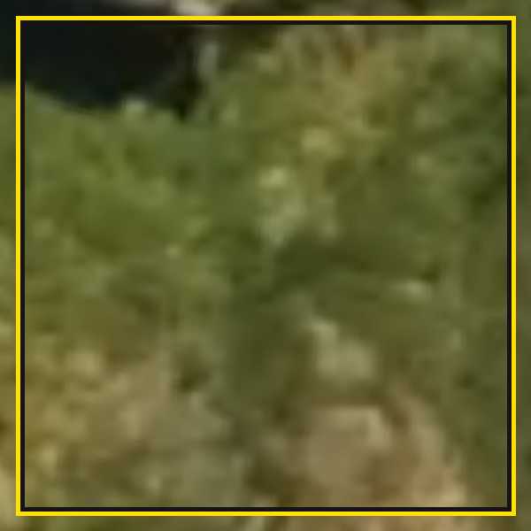 | Grass and low herbaceous cover | Gramado ou vegetação rasteira | Uniform green tone, fine and even texture, at ground level; no self-shadow; lacks the granular texture of shrubs.
2 | Vegetation | 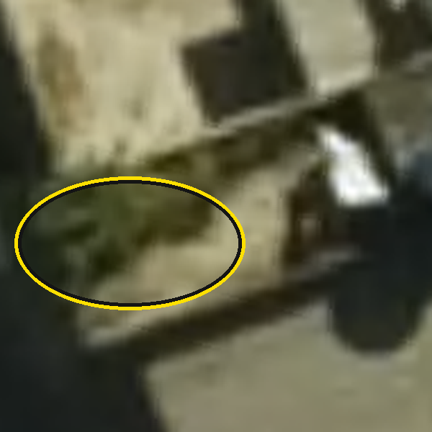 | Ornamental plants, shrubs, small trees | Plantas ornamentais, arbustos ou árvores de pequeno porte | Small localised green clusters, intermediate texture, minimal shadow; site association with slab (laje) edges and balconies.
3 | Vegetation | 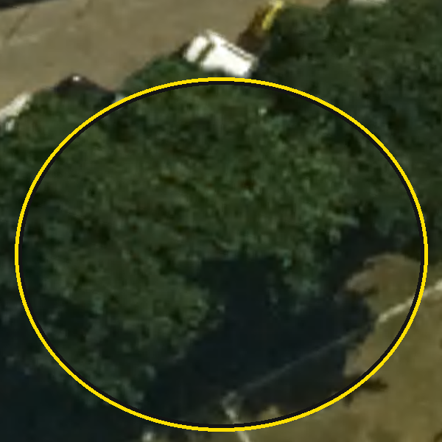 | Mature trees | Árvores propriamente ditas | Coarse, irregular “popcorn” texture; crown typically >2 m across; casts a long shadow proportional to height — shadow length is the primary discriminant from class 2.
4 | Roofing | 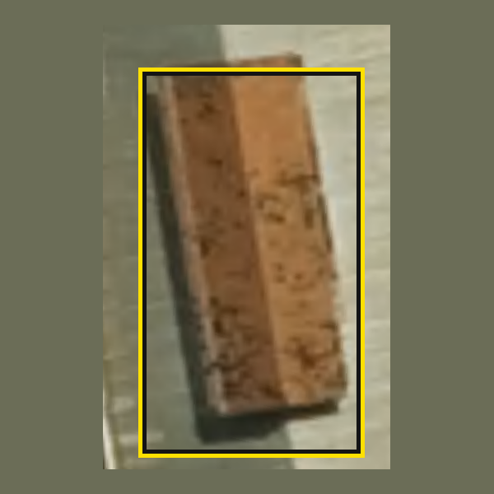 | Clay tile roof | Telhado de telhas cerâmicas (coloniais) | Orange to terracotta tone; regular fine linear texture from tile courses; opaque; site association with older structures.
5 | Roofing | 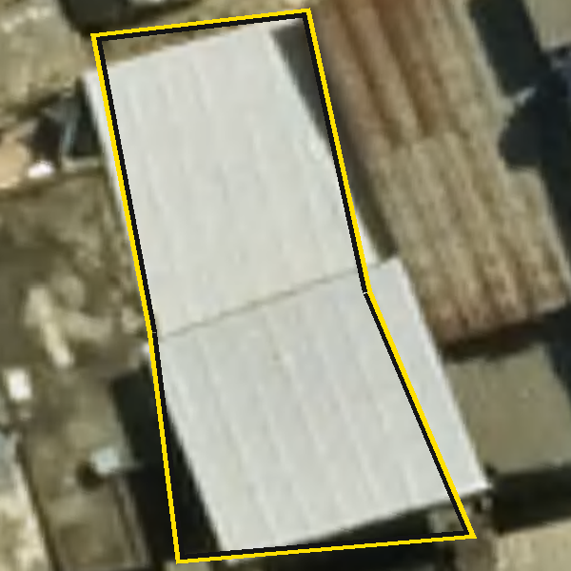 | Bright corrugated metal | Telhado de metal branco refletivo e ondulado | Very bright tone; regular parallel rib pattern; rigid straight edges casting sharp shadows on adjacent structures.
6 | Roofing | 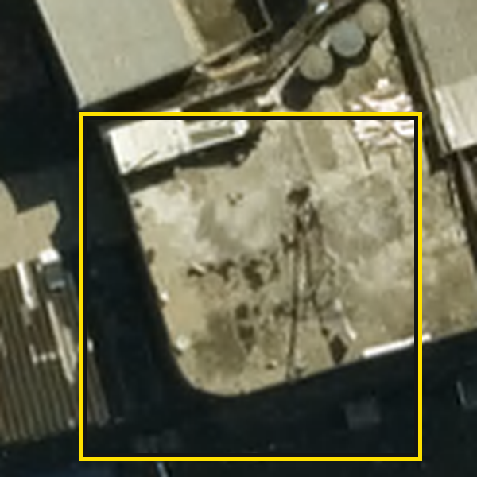 | Unsealed concrete slab | Laje de cimento sem impermeabilização | Neutral grey tone, matte and largely untextured; frequent site association with water tanks; may carry minor debris or storage.
7 | Roofing | 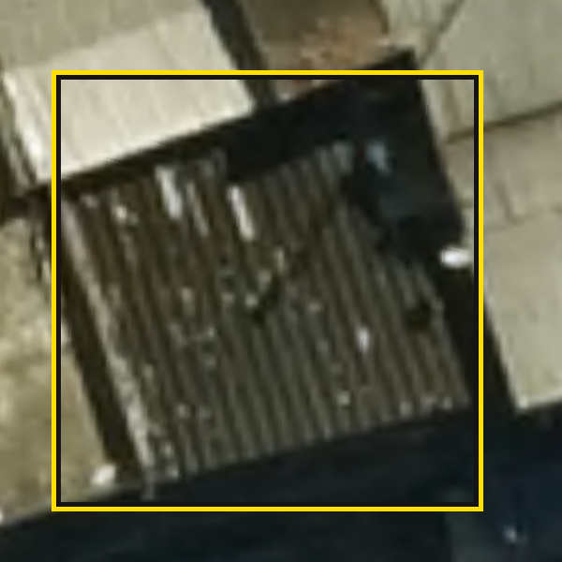 | Fibre-cement or asbestos sheeting | Telhado de fibrocimento ou amianto | Dull grey to blue-grey tone; corrugated texture as in class 5 but without the bright tone; rhythmic ridges distinguish it from class 6.
19 | Roofing | 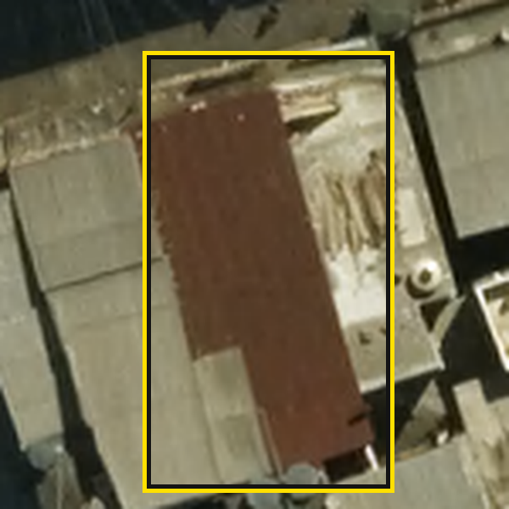 | Rusted metal roofing | Telhado de metal com ferrugem | Corrugated texture as in class 5, with mottled brown to dark red patina and loss of brightness. Classify on the rib pattern, not on tone.
23 | Roofing | 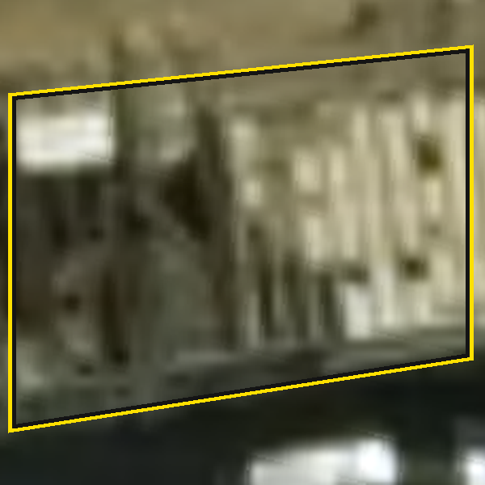 | Degraded mixed-material slab | Laje mista degradada | Visually heterogeneous within a single roof plane: patchwork of fibre-cement, metal and concrete textures; high visual noise, no dominant pattern.
24 | Roofing | 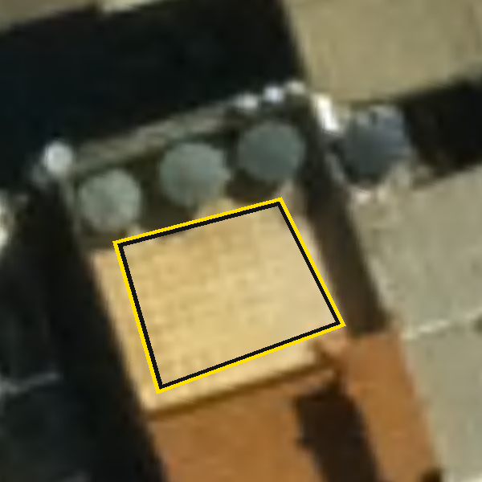 | Finished/paved concrete slab | Laje revestida (com piso) | Uniform smooth texture, beige, white or terracotta tone; lacks the surface clutter of class 8 and appears more finished than class 6.
26 | Roofing | 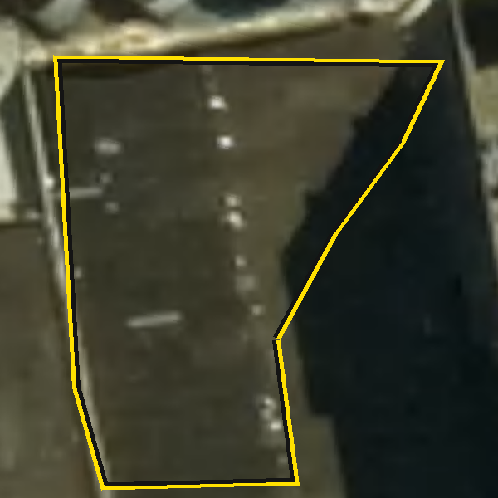 | Sealed/waterproofed slab | Laje com impermeabilização | Dark grey to black (bituminous) or uniformly coated tone; more homogeneous than class 6; membrane seam lines may be visible; no corrugation.
8 | Private / enclosed space | 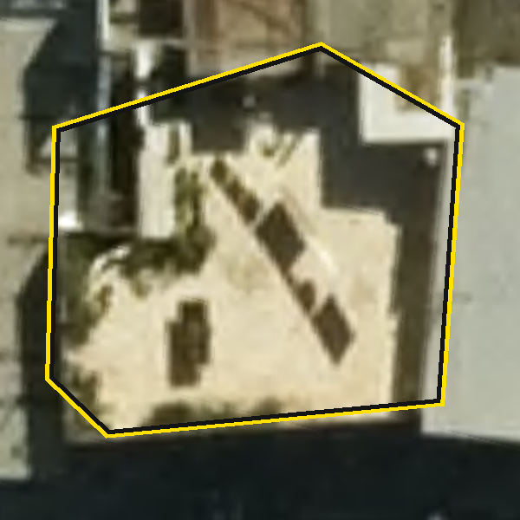 | Social terrace or active balcony | Quintal, balcão ou terraço (uso social) | Elevated slab showing evidence of use: thin linear shadows (laundry lines), point objects (furniture, pots); clear signs of social transit.
21 | Private / enclosed space | 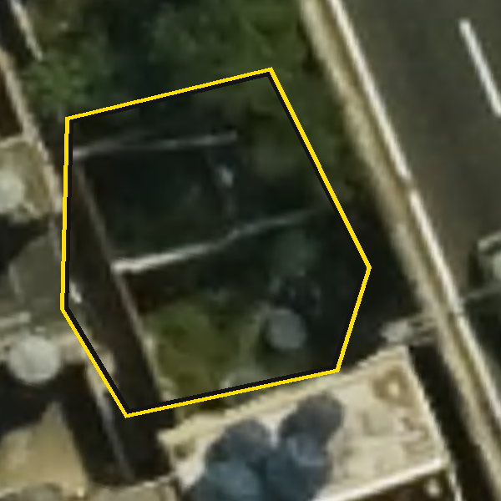 | Vegetated internal courtyard | Quintal interno com vegetação | Ground- or low-level open space enclosed by buildings, with grass or planting; distinguished from class 2 by the absence of an underlying slab.
22 | Private / enclosed space | 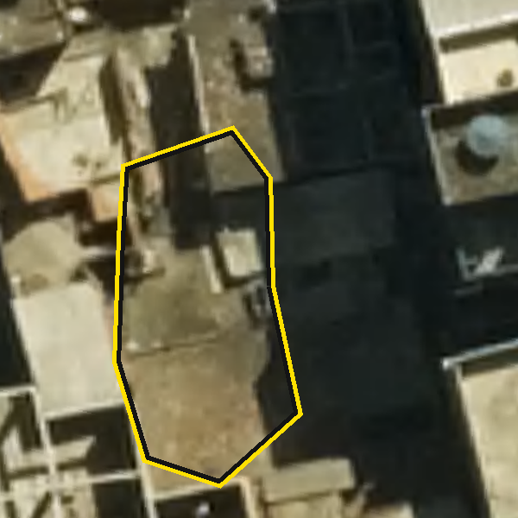 | Non-vegetated internal courtyard | Quintal interno sem vegetação | As class 21 but with bare earth or concrete floor; inward-facing shadows confirm that it sits below the surrounding roof plane.
9 | Construction & debris | 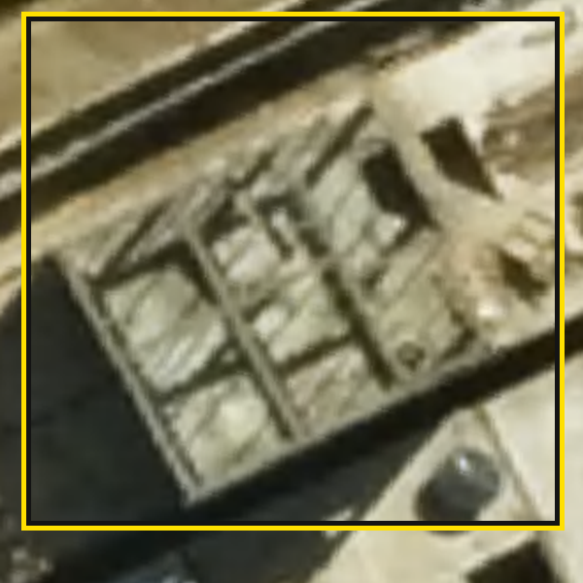 | Active construction site (roofless) | Área de construção (sem telhado) | Hollow appearance; internal partition walls casting shadows within the polygon; exposed brick tone or raw columns with no top cover.
10 | Construction & debris | 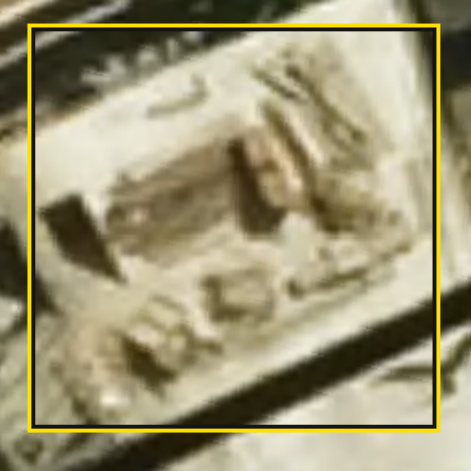 | Slab with heavy debris | Laje de cimento com muito entulho | Grey base tone largely obscured by chaotic multi-tone texture; sharp irregular shadows from stacked material.
11 | Open & public ground | 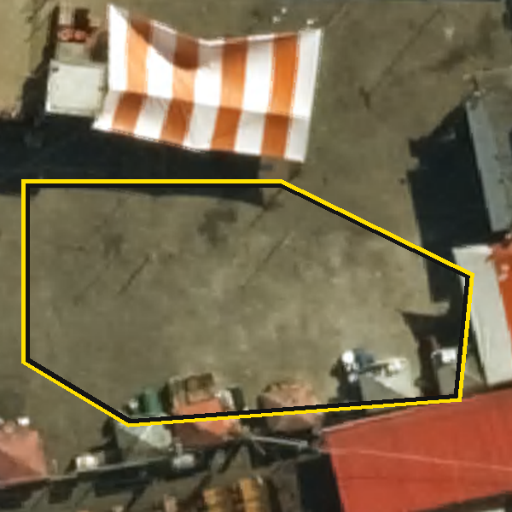 | Ground-level public courtyard | Quintal ou espaço público (nível do solo) | Large open area at settlement base level; sparse vegetation; may contain vehicles or temporary structures; no height-relative shadow.
12 | Open & public ground | 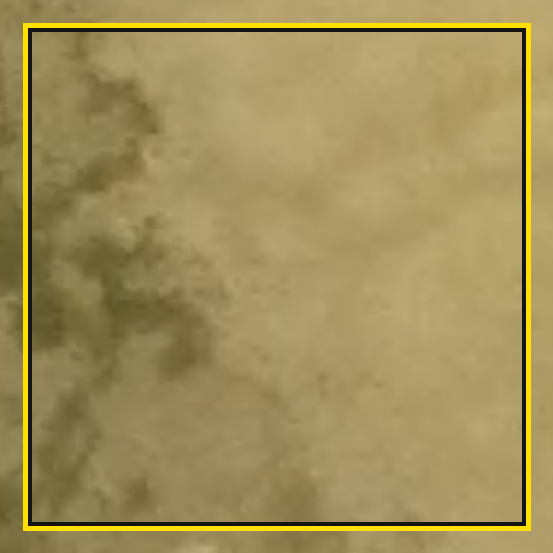 | Vacant or undeveloped lot | Terreno baldio | Indistinct boundaries; mixed bare earth and sporadic weeds; no organised infrastructure and no sign of active use.
13 | Open & public ground | 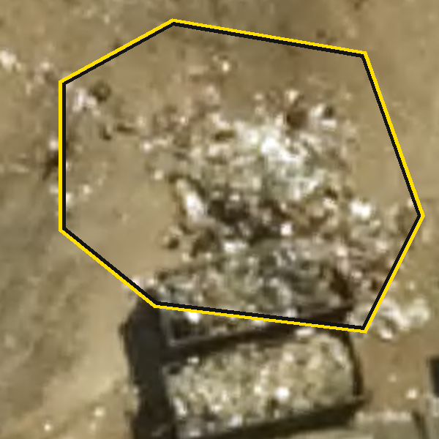 | Waste accumulation or dump site | Lote com lixo ou descarte de resíduos | Highly irregular, strongly varied tone (plastics, fabric); chaotic texture distinct from the angular texture of construction debris (class 10).
14 | Leisure | 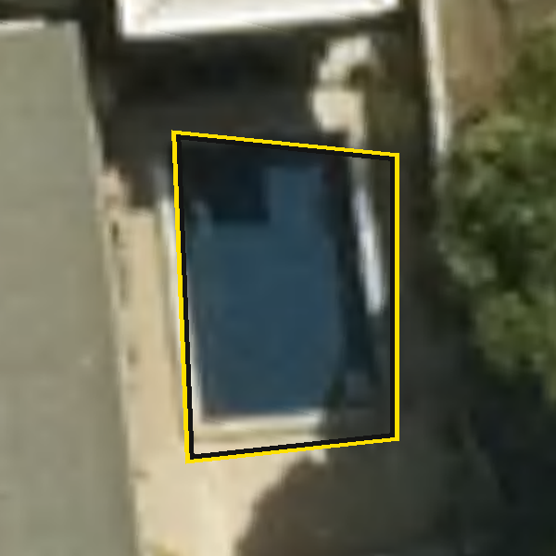 | Swimming pool (fixed or inflatable) | Área de lazer com piscina | Distinctive cyan to bright blue tone; rectangular or circular shape; site association with upper slabs and water tanks; brighter than blue roofing.
15 | Leisure | 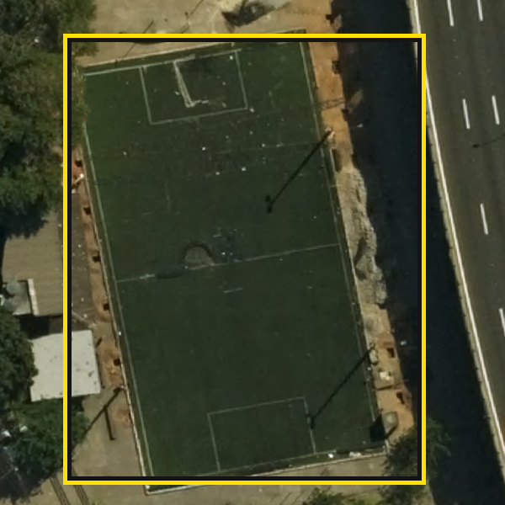 | Recreational facility | Área de lazer (parque, quadra, academia) | Ground level; sports courts show clear geometric boundaries and markings; playgrounds show high-contrast multi-tone point objects.
16 | Circulation & parking | 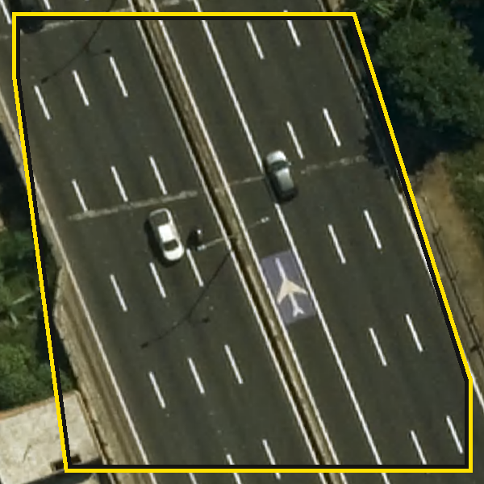 | Main external thoroughfare | Avenida externa | Wide, continuous, smooth-textured corridor with lane markings and high vehicle density; runs outside or along the settlement edge.
17 | Circulation & parking | 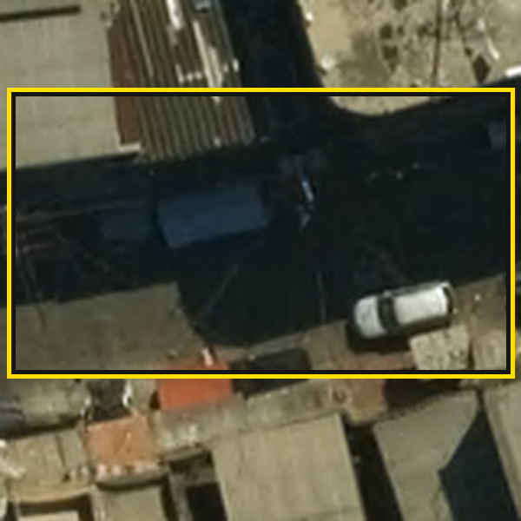 | Internal favela road | Estrada interna da favela | Narrower and of irregular width; usually unmarked; surface varies from asphalt to concrete or earth; follows the organic settlement layout.
20 | Circulation & parking | 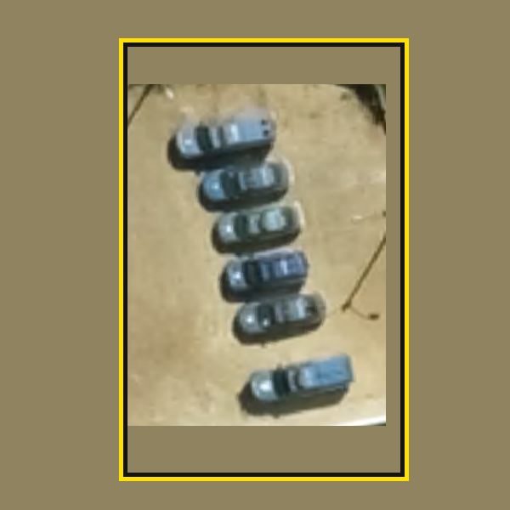 | Formal or informal parking | Estacionamento | High density of vehicles, in rows (formal) or clustered (informal); at ground level or on large dedicated slabs.
28 | Circulation & parking | 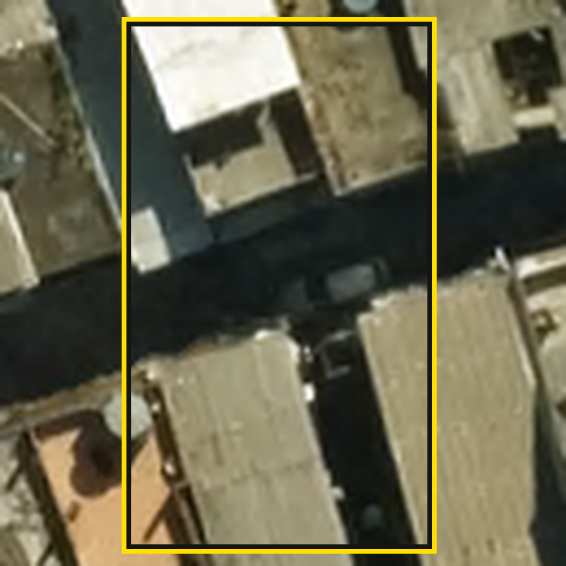 | Narrow internal alley / dead end | Beco interno | Very narrow passage (often <1.5 m); deep persistent shadow is the primary signature; frequently partly occluded by eaves and cabling.
18 | Hydrology | 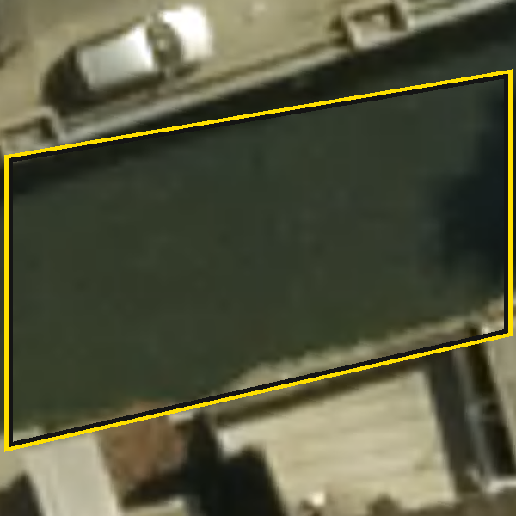 | Polluted open channel | Valão ou rio poluído | Linear feature, dark and uniform tone, no surface texture; depressed relative to adjacent ground; site association with internal roads and outfalls.
25 | Commercial & energy | 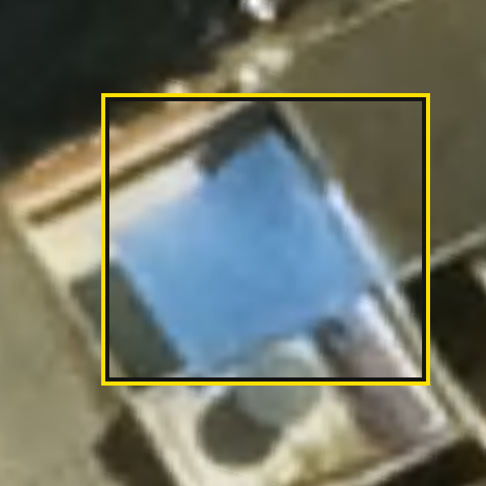 | Canvas, awning or market tent | Lona ou toldo (comercial) | Strongly saturated tone (blue, yellow, striped); non-rigid, irregular edges; site association with street markets and commercial frontages.
27 | Commercial & energy | 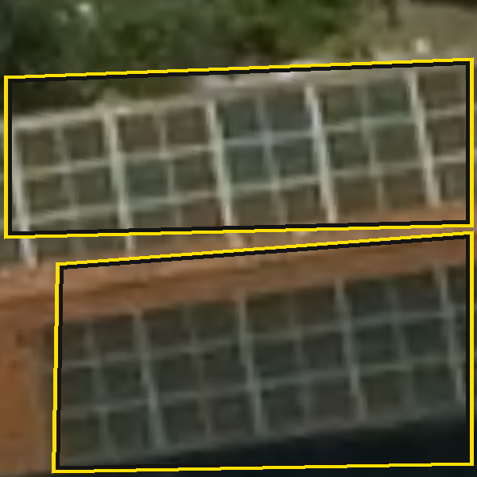 | Photovoltaic panels | Painéis solares | Dark blue to black rectangular grid; strongly geometric, repetitive pattern; consistent orientation across a roof plane.
Recalibration. The examples are calibrated to this imagery source, sampling distance, season and solar angle. Applied to imagery differing in any of these respects they remain indicative rather than definitive, and a local review of the class set should precede use elsewhere.
Attribution: Instituto Pereira Passos, Prefeitura da Cidade do Rio de Janeiro, CC BY 4.0.

Annexe — Format compatibility test data
Synthetic test data are distributed with bufferscape in both GeoPackage and KML, comprising a synthetic set of points with polygon and container layers spanning the full class list. The two files describe the same synthetic site and the package’s test suite asserts that they produce identical output, so a user may verify format compatibility without access to any study data. The synthetic site bears no relation to any real study area.

